Shiv Nadar University
End Semester Examinations, 2022-2023 Even
Question Paper
Name of the Programme: B.Tech-CSE (Cyber), AI & DS |  |  | Semester: III
Course Code & Name: CS2701 & OPERATING SYSTEMS + Lab
Regulation 2021
Time: 3 Hours |  | Maximum: 100 Marks

Q.No |  | Answer All the Questions | Marks | CO# | KL#
1 | a | ------------- provides a convenient environment for program development and execution.  - System Programs  - System goals  - Booting  - Registers | 1 | CO1 | KL1
2 | a | State TRUE or FALSE.  A program to compute the sum of first 10,000 numbers can be divided into 4 sub parts and executed on four CPUs using either fork or threads. The reason why we prefer threads is because large portions of the data/code between the 4 sub parts are very similar and need not be duplicated.  - TRUE  - FALSE | 1 | CO2 | KL1
3 | a | An operating system implements a policy that requires a process to release all resources before making a request for another resource. Which of the following is true based on above statement?  - Both starvation and deadlock can occur.  - Starvation can occur but deadlock cannot occur.  - Starvation cannot occur but deadlock can occur  - Neither starvation nor deadlock occur | 1 | CO2 | KL1
4 | a | To access the services of the operating system, the interface is provided by the  - Library  - System Calls  - Assembly instructions  - API | 1 | CO3 | KL1
5 | a | The _________ presents a uniform device-access interface to the I/O subsystem, much as system calls provide a standard interface between the application and the operating system  - Device drivers  - I/O systems  - Devices  - Buses | 1 | CO5 | KL2
6 |  | Give the difference between internal fragmentation and external fragmentation. Which one occurs in paging? | 2 | CO1 | KL1
7 |  | Differentiate between processes and threads with appropriate example. | 2 | CO2 | KL2
8 |  | What is Race-around condition in process synchronization? Explain with an example. | 2 | CO3 | KL2
9 |  | What is starvation in CPU scheduling? Which kind of scheduling algorithms lead to starvation? | 2 | CO4 | KL2
10 |  | What is thrashing in Demand Paging? Mention its impact on the degree of multiprogramming. | 2 | CO4 | KL3
11 |  | Explain Peterson’s solution for the critical section problem. Discuss its limitations. | 5 | CO3 | KL2
12 |  | Assume a process creates multiple child processes using fork() system call. How can you program the parent process to wait until all its child processes terminate before terminating itself? | 5 | CO4 | KL3
13 |  | What is Copy – on – write feature? What advantages does it provide for the operating system? | 5 | CO4 | KL2
14 |  | Consider the following segment table.  Segment No. Base Length  0 1219 700  1 2300 14  2 90 100  3 1327 580  4 1952 96  Which of the following logical address will produce trap addressing error? Calculate the physical address if no trap is produced.  - 0, 430  - 1, 11  - 2, 78  - 3, 425  - 4, 95  - 0, 701  - 1, 100  - 2, 102  - 3, 585  - 4, 100 | 10 | CO1 | KL1
15 |  | Consider the traffic deadlock depicted in the following figure.  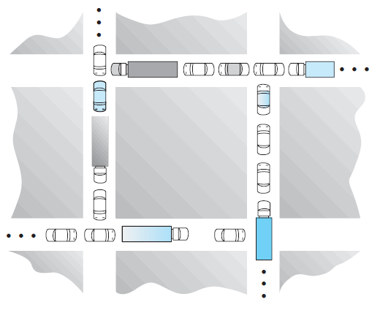  - Show that the four necessary conditions for deadlock hold in this example.  - State a simple rule for avoiding deadlocks in this system. | 10 | CO4 | KL2
16 |  | In a 1024-KB segment, memory is allocated using the buddy system. Draw a tree illustrating how the following memory requests are allocated:  - Request 6 KB  - Request 250 bytes  - Request 1500 bytes  Next, modify the tree for the following releases of memory. Perform coalescing whenever possible.  - Release 250 bytes  - Release 1500 bytes | 10 | CO5 | KL1
17 |  | Suppose that a disk drive has 5000 cylinders, numbered 0 to 4999. The drive is currently serving a request at cylinder 2150 and the previous request was at cylinder 1805. The queue of pending request is  2069, 1212, 2296, 2800, 544, 1618, 356, 1523, 4965, 3681.  Starting from the current head position, what is the total distance the disk arm moves to satisfy all the pending requests for each of the following disk-scheduling algorithms?  - FCFS  - SSTF  - SCAN  - C-SCAN  - LOOK | 10 | CO5 | KL2
18 |  | Discuss some of the issues to consider in designing multithreaded programs with suitable examples. | 10 | CO3 | KL4
19 |  | Discuss the different scheduling criterions to consider before designing a CPU scheduling algorithm. | 10 | CO4 | KL4
20 |  | Discuss different services an Operating System is expected to provide for the end user. | 10 | C01 | KL1

KL – Bloom’s Taxonomy Levels
(KL1: Remembering, KL2: Understanding, KL3: Applying, KL4: Analyzing, KL5: Evaluating, KL6: Creating)
CO – Course Outcomes
--------------

